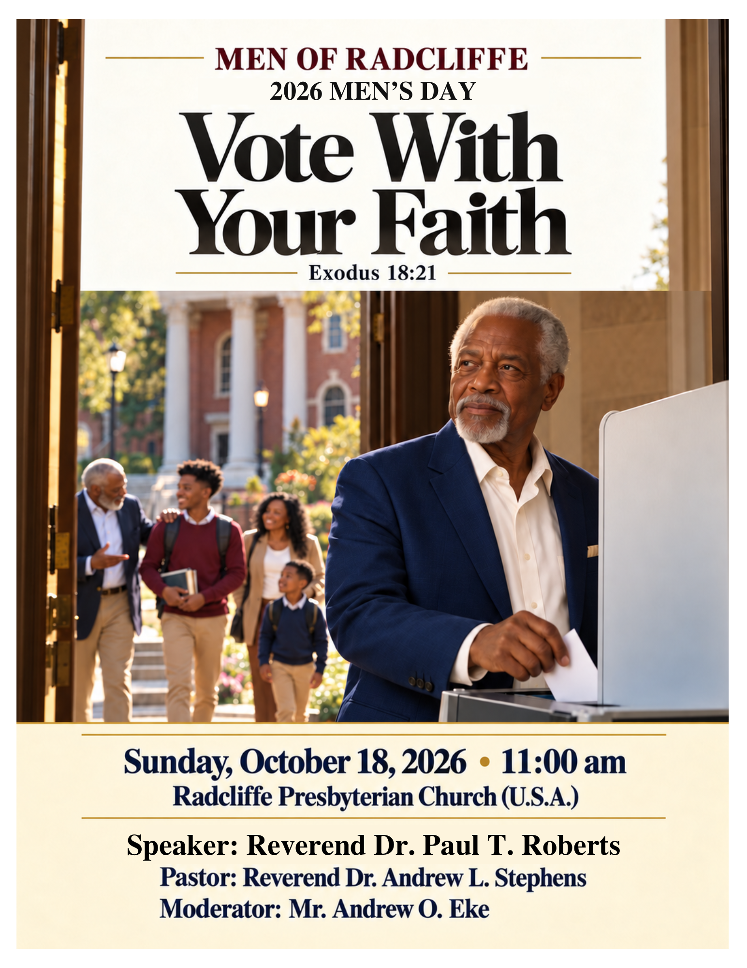

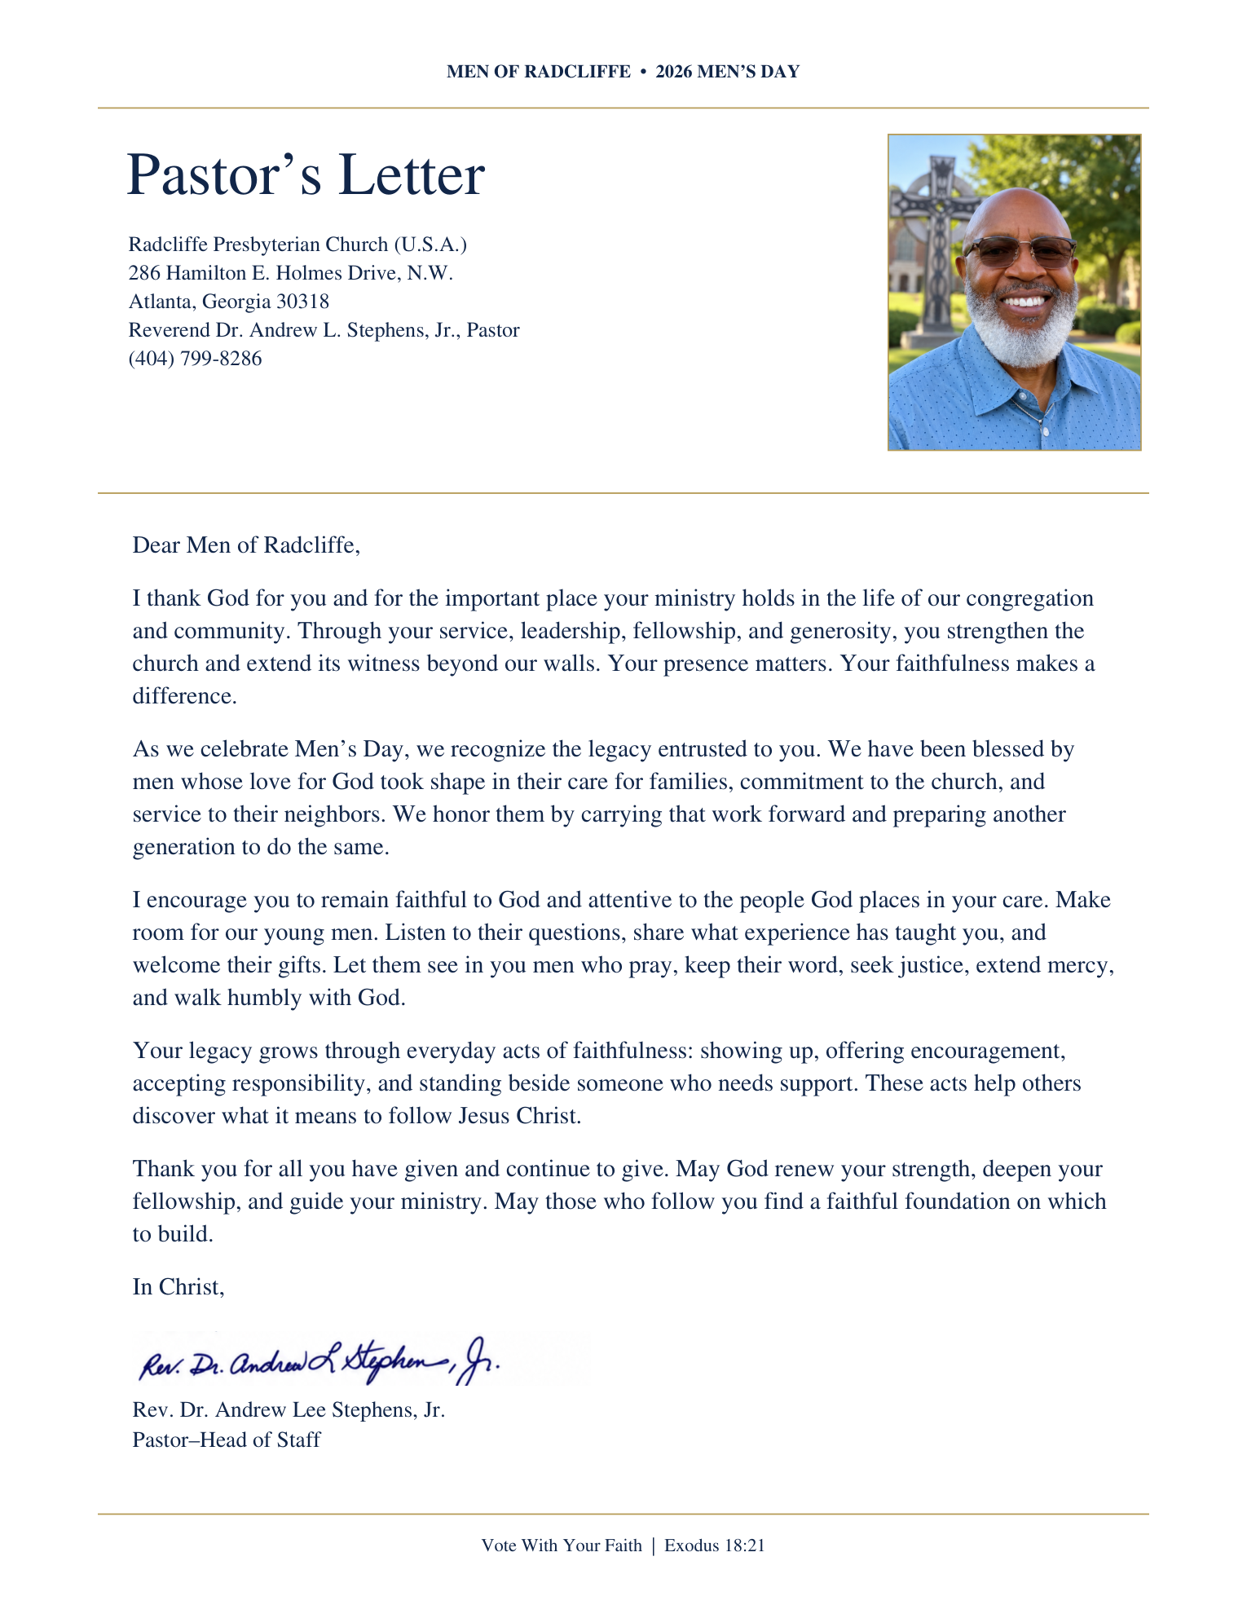
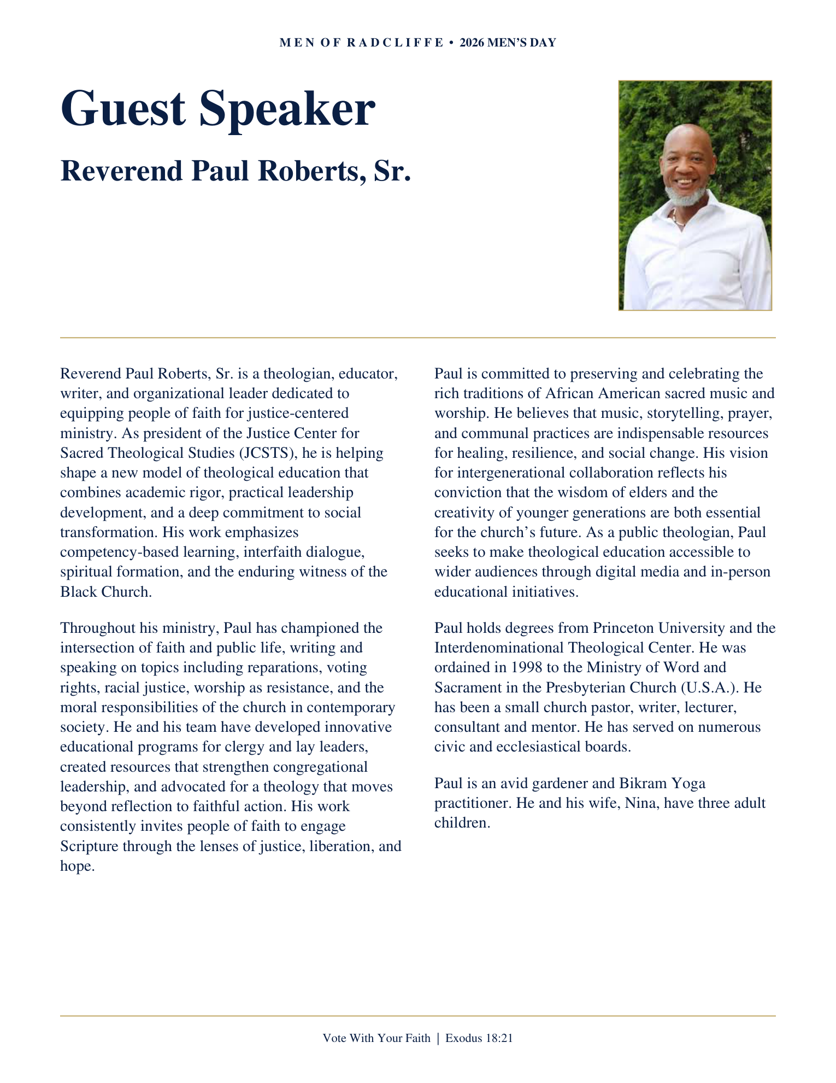
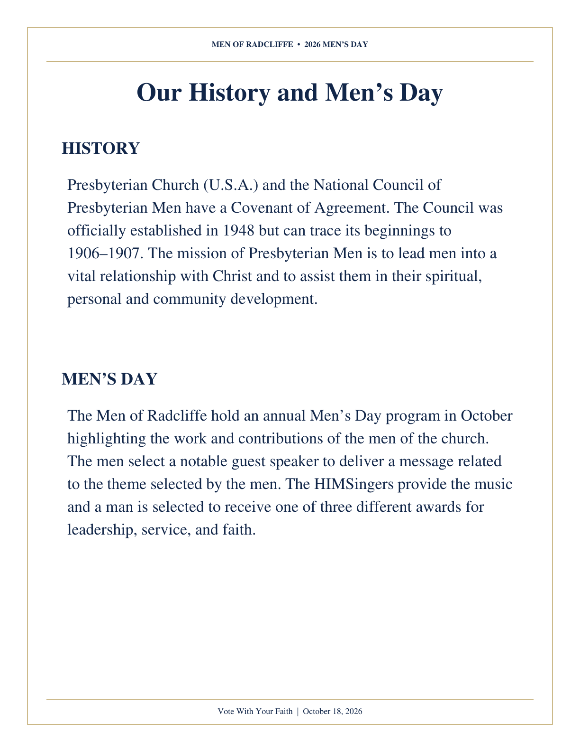

Order of Worship
2026 MEN’S DAY • OCTOBER 18 • 11:00 A.M.
Rev. Dr. Paul Roberts, Sr., Guest Preacher
Dr. Alfred E. McWilliams, Liturgist
Music: HIMSingers, under the direction of Mr. Jonathan McGill

Gathering in God’s Presence

Introit

Call to Worship
Leader: The Lord be with you!
People: And also with you.
Leader: Come, let us worship the Lord, the King of kings and Lord of lords.
People: God is the one who establishes the seasons, who rules over nations, and whose kingdom will never end.
Leader: As we enter this season of voting and choosing leaders, we lift our eyes above the noise of campaigns and political debates.
People: We place our trust not in human power or political parties, but in Almighty God.
Leader: As disciples of Jesus Christ, we are called to a high standard of citizenship.
People: Lord, give us wisdom as we vote, humility as we serve, and respect for those who govern.
Leader: Let us cast aside division and anxiety, bowing our hearts in unity before the Sovereign God.
All: Come, let us worship and adore God together!

Occasion

Opening Hymn
“Faith of Our Fathers”

Order of Worship Continued
2026 MEN’S DAY • OCTOBER 18 • 11:00 A.M.

Call to Confession
Dietrich Bonhoeffer once warned the church against the deadly enemy of “cheap grace”—the grace we bestow upon ourselves, the preaching of forgiveness without requiring repentance, and discipleship without the cross. “Costly grace” calls us to follow Jesus, confronting us in our comfort and demanding our obedience in all areas of life, including how we care for our communities and our nation. Therefore, let us confess our sins before Almighty God.

Prayer of Confession (Unison)
Gracious God our Father and our Mother, we confess we have often chosen cheap grace. We have accepted your love but rejected your call to action. We confess that we have neglected our civic responsibilities, passing by the ballot box out of cynicism, laziness, or fear. We have failed to act as faithful stewards of the freedom and influence you have given us. Forgive us for hiding behind a comfortable faith. Break our hearts for what breaks yours and grant us the courage of costly grace to vote and to serve as active witnesses of your kingdom. In Jesus’ name we pray. Amen.

Assurance of Pardon
Leader: Hear the good news of the Gospel: God’s grace is never cheap, but it is always free. It cost God the life of God’s Son to break the power of our apathy, cynicism, and political divisions. Christ died to set us free from the guilt of our past sins. Hear and believe the truth that settles all things: in Jesus Christ, we are completely forgiven, loved, and fully restored.
People: Thanks be to God! We are forgiven, and we are free.

Order of Worship Continued
2026 MEN’S DAY • OCTOBER 18 • 11:00 A.M.

Affirmation of Faith (Unison)
Excerpt from A Brief Statement of Faith, Presbyterian Church USA
In a broken and sinful world, the Spirit gives us courage to pray without ceasing, to witness among all peoples to Christ as Lord and Savior, to unmask idolatries in church and culture, to hear the voice of peoples long silenced and to work with others for justice, freedom and peace. In gratitude to God, empowered by the Spirit, we strive to serve Christ in our daily tasks and to live holy and joyful lives, even as we watch for God’s new heaven and new earth, praying, “Come, Lord Jesus!”

Hearing God’s Word

Prayer for Illumination

Scripture Readings
Old Testament: Exodus 33:12–23
Gospel: Matthew 22:15–22

Introduction of the Guest Preacher
Mr. Charles F. Easley, Jr.

Solo
“My Soul Has Been Anchored” — Mr. James Barringer

Sermon
Rev. Dr. Paul Roberts

Invitation

Order of Worship Continued
2026 MEN’S DAY • OCTOBER 18 • 11:00 A.M.

Celebrating the Lord’s Supper

Responding to God’s Word

Offering of Tithes and Gifts
Mr. Alfred Douglas Ellis, Jr.

Celebrating Excellence & Service: Awards & Recognition
Andrew O. Eke & William Boyd

Moderator’s Remarks and Acknowledgements

2026 Church Man of the Year

Outstanding Leadership Award

Outstanding Service Award

Man of Faith Award

In Memoriam
Alfred Douglas Ellis, Jr.

Closing Hymn
O God Our Help in Ages Past — HIMSingers and Congregation

Charge and Benediction
Rev. Dr. Paul Roberts, Sr.

Blessing of the Meal
Rev. Dr. Paul Roberts, Sr.

Postlude

Reception
Lloyd Green Multipurpose Room

