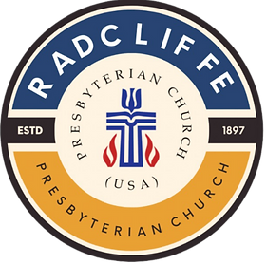

Radcliffe Presbyterian Church (USA)
Worship Service for The Lord’s Day
February 8, 2026.

Rev. Dr. Andrew L. Stephens Jr.

286 Hamilton E. Holmes Dr. NW
Atlanta GA, 30318.

We Gather (Welcome) Minister Chase Garrison

Call to Worship Blessed are those who fear the Lord and delight in God’s commandments. They rise as light in the darkness, gracious, merciful, and righteous. Jesus declares, You are the light of the world. Come, let us worship the Lord.

Opening Hymn EverySunday Choir

Call to Confession Minister James Jr. Koranteng

Prayer of Confession Merciful God, you call us to be salt of the earth and light of the world, yet we confess that our witness is often dim and our faith loses its savor. We seek you with our words, but resist your call with our actions. We long to be seen as righteous, yet fail to live lives shaped by justice, mercy, and love. Forgive us for the ways we have ignored the needs of the hungry, the oppressed, and the forgotten. Renew us by your Spirit, that our lives may reflect the light of Christ and bring glory to your name Amen.
Declaration of Forgiveness Minister James Koranteng

Apostles Creed Congregation
Congregational Song Congregation

Announcement Minister James Jr. Koranteng

The Word
Scripture Reading Minister James Jr. Koranteng

Inspirational EverySunday Choir

Sermon Minister Chase Garrison

Invitational Song EverySunday Choir

Charge and Blessing Minister Chase Garrison

Postlude EverySunday Choir

Lectionary Readings
Isaiah 58:1-9a Psalm 112:1-9 1 Corinthians 2:1-12
Matthew 5:13-20

TWO TAKEAWAYS PLUS

