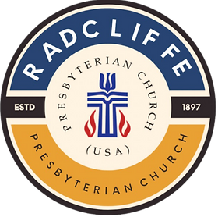

Radcliffe Presbyterian Church (USA)
Worship Service for The Lord’s Day
March 1st, 2026.

Rev. Dr. Andrew L. Stephens Jr.

286 Hamilton E. Holmes Dr. NW
Atlanta GA, 30318.

We Gather (Welcome) Pastor

Prayer for the People Elder Cindy Kai Dockett

Scripture Reading Psalm 121

Inspirational Song EverySunday Choir

Sermon Pastor

Invitation Pastor

Litany of Confession Leader: God of promise, You call us to trust You and to go where You lead.
People: Yet we cling to what is familiar. We fear the journey of faith.
Leader: You are our keeper; our help comes from You.
People: But we look to ourselves for security and try to control what belongs to You.
Leader: You reckon faith as righteousness and ground Your promise in grace.
People: Forgive us for trying to earn what You freely give.
Leader: In Christ You call us to be born from above.
People: Renew us by Your Spirit. Free us from fear.
Lead us into new life.
All: For You did not send the Son to condemn the world,
but that the world might be saved.
Have mercy on us, O God.
Amen.
Holy Communion Pastor

Apostles Creed Congregation

Congregational Song Congregation

Ordination & Installation Pastor

Offering Pastor

Black History Moment Elder Chuck/Zaida

Announcement Pastor

Charge and Blessing Pastor

Postlude EverySunday Choir
Lectionary Readings
Genesis 12:1–4a Psalm 121 Romans 4:1–5, 13–17
John 3:1–17

TWO TAKEAWAYS PLUS

