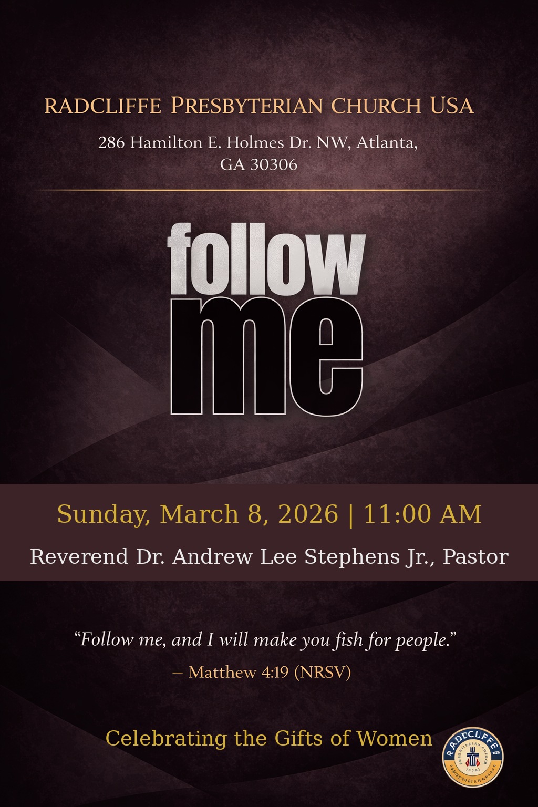
ORDER OF WORSHIP
────────────────────────────
Scripture Readings
Opening Prayer
Inspirational
Proclamation of the Word
Invitation
Confession
Congregational Song
Offering
Special Presentation
Celebrating the Gifts of Women
Announcements
Charge
Blessing and Benediction
Postlude

ORDER OF WORSHIP
────────────────────────────
Scripture Readings
Opening Prayer
Inspirational
Proclamation of the Word
Invitation
Confession
Congregational Song
Offering
Special Presentation
Celebrating the Gifts of Women
Announcements
Charge
Blessing and Benediction
Postlude

SCRIPTURE READINGS
────────────────────────────
Third Sunday in Lent — Year A

First Reading — Exodus 17:1–7
Psalm — Psalm 95
Second Reading — Romans 5:1–11
Gospel — John 4:5–42
LITANY OF CONFESSION
────────────────────────────
Leader:
God of the wilderness and the well,
You have walked with us through every dry place.
People:
Yet we have questioned Your presence.
Leader:
When the ground felt cracked beneath our feet,
When resources felt scarce,
When the journey felt long—
People:
We quarreled instead of trusting.
We tested instead of believing.
Leader:
You stood upon the Rock before Your people,
And water flowed.
People:
Still, we asked, “Are You among us?”
Leader:
You call to us even now:
“O that today you would hear My voice.”
People:
But we have hardened our hearts.
Leader:
We have come to worship
Yet guarded our spirits.
We have heard Your Word
Yet resisted its work within us.
People:
Forgive us, Lord.
Leader:
At the well, Your Son offered Living Water.
Water that becomes a spring within.
Water that satisfies deeper thirst.
People:
Yet we return to old wells.
We cling to empty jars.
We seek life in what cannot sustain us.
Leader:
While we were still weak,
Christ died for us.
Your love has been poured into our hearts
Through the Holy Spirit.
People:
Yet we have not fully received what You have poured.
Leader:
Merciful God,
Soften what has hardened in us.
Quench what is restless in us.
Cleanse what is broken in us.
People:
Teach us to drink deeply of Christ.
Leader:
Strike the Rock again upon our stubborn hearts.
Let Living Water flow within us.
People:
We turn to You.
We trust You.
We receive Your grace.
All:
In Jesus Christ, the Living Water,
forgive us, renew us, and lead us.
Amen.

CONGREGATIONAL SONG
────────────────────────────
Pass Me Not, O Gentle Savior

Pass me not, O gentle Savior
Hear my humble cry
While on others Thou art calling
Do not pass me by
Savior, Savior
Hear my humble cry
While on others Thou art calling
Do not pass me by

Let me at Thy throne of mercy
Find a sweet relief
Kneeling there in deep contrition
Help my unbelief
Savior, Savior
Hear my humble cry
While on others Thou art calling
Do not pass me by

Trusting only in Thy merit
Would I seek Thy face
Heal my wounded, broken spirit
Save me by Thy grace
Savior, Savior
Hear my humble cry
While on others Thou art calling
Do not pass me by

Thou the spring of all my comfort
More than life to me
Whom have I on earth beside Thee?
Whom in Heav'n but Thee?
Savior, Savior
Hear my humble cry
While on others Thou art calling
Do not pass me by

While on others Thou art calling
Do not pass me by

WORSHIP PARTICIPANTS
────────────────────────────
Scripture Reader — Elder Zettler Clay
Opening Prayer — Elder Zettler Clay
Inspirational — Every Sunday Choir
Litany of Confession — Elder Zettler Clay
Proclamation of the Word — Rev. Dr. Andrew Lee Stephens, Jr.

