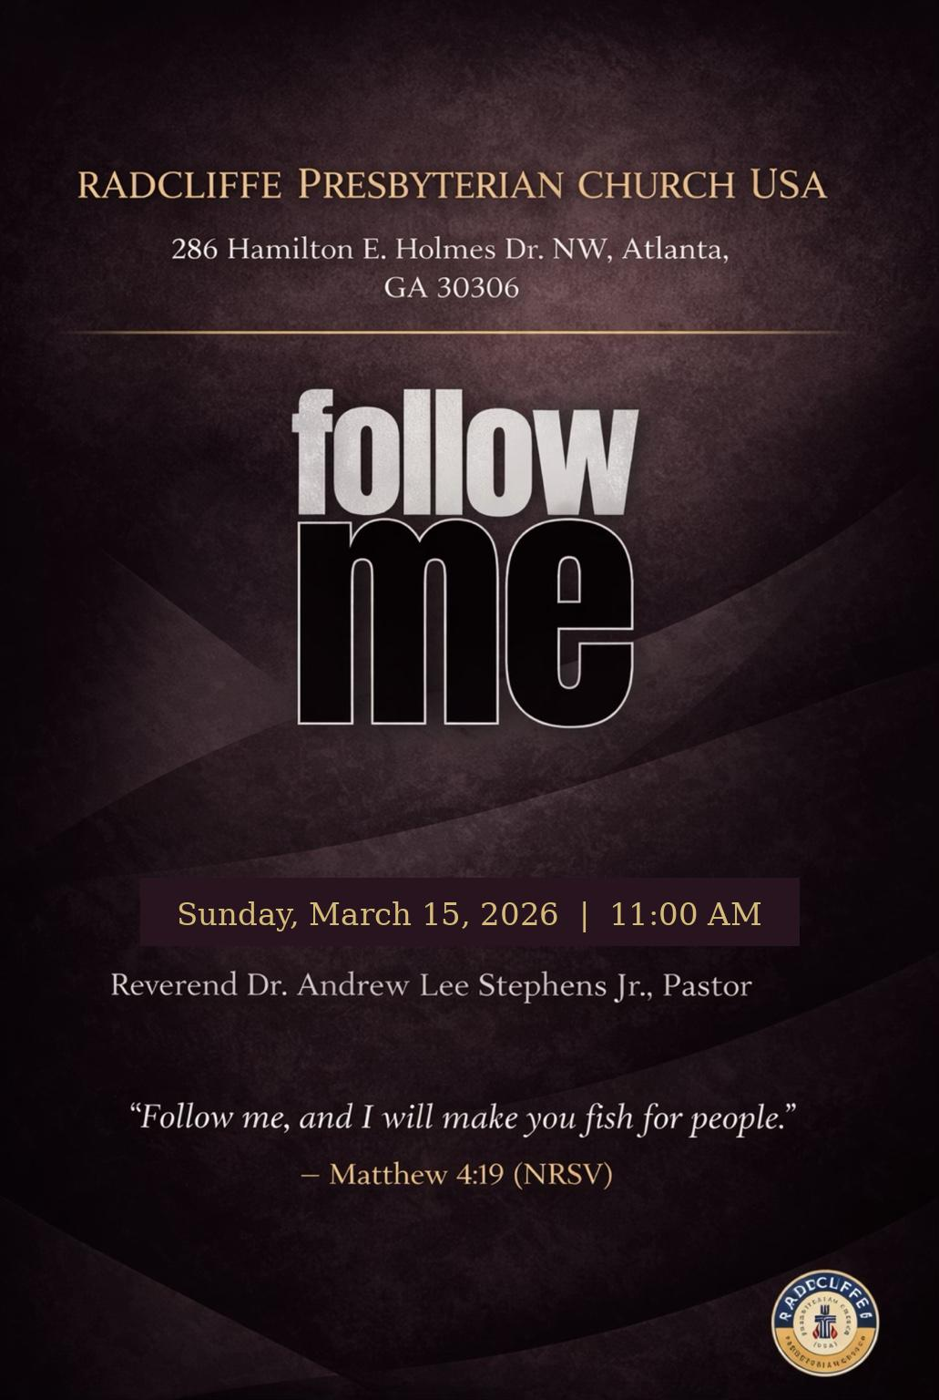

ORDER OF WORSHIP
────────────────────────────
Scripture Readings
Opening Prayer
Inspirational
Proclamation of the Word
Invitation
Confession
Communion
Apostles Creed
Congregational Song
Offering
Announcements
Charge
Blessing and Benediction
Postlude

LITANY OF CONFESSION
────────────────────────────
Fourth Sunday in Lent
Leader:
God of light and truth,
You see what we often fail to see.
People:
You look upon the heart,
while we judge by outward appearance.
Leader:
You call us out of darkness into light.
People:
Yet we confess that we often prefer the shadows.
Leader:
Like Samuel, we have been quick to judge by what we see.
People:
We overlook those whom You have chosen
and fail to recognize Your work among us.
Leader:
Like the crowds in Jerusalem,
we assume suffering must be someone’s fault.
People:
We close our eyes to compassion
and our hearts to understanding.
Leader:
Like the Pharisees,
we claim that we see clearly.
People:
Yet our pride blinds us
to Your truth and Your grace.
Leader:
Forgive us, Shepherd of our souls.
People:
Lead us beside still waters.
Restore our souls.
Leader:
Awaken us from the sleep of sin.
People:
Shine Your light upon us, O Christ.
Leader:
Open our eyes to Your presence in our lives.
People:
So that we may say with gratitude and faith:
All:
“Though we once were blind,
now we see.”
Amen.
CONGREGATIONAL SONG
────────────────────────────
Walk In The Light
(written by G. Elderkin)

Chorus:
Walk in the light, beautiful light,
come where the dewdrops of mercy shine bright.
Oh shine all around us by day and by night,
Jesus is, Jesus is the light of the world;

Oh we shall walk in the light, beautiful light,
come where the dewdrops of mercy shine bright.
Oh shine all around us by day and by night,
Jesus is , Jesus is the light of the world;

Verse 1:
No need to worry, no need to fret,
all of my needs, the man named Jesus has met.
His love protects me from hurt and from harm,
Jesus is, Jesus is the light of the world.

Verse 2:
If the gospel be hid, it's hid from the lost,
my Jesus is waiting to look past your faults.
Arise and shine, your light has come,
Jesus is, I know that He is the only light of this world.

SCRIPTURE READINGS
────────────────────────────
Fourth Sunday in Lent — Year A
First Reading — 1 Samuel 16:1–13
Psalm — Psalm 23
Second Reading — Ephesians 5:8–14
Gospel — John 9:1–41
PARTICIPANTS
────────────────────────────
Worship Leader
Minister Chase Garrison

Scripture Reader
Minister Chase Garrison

Music Ministry
Every Sunday Choir

Media Ministry
Reginald Simpson

Elder Chuck Easley
Lamont Ryant
Elder Andrew Lee Stephens, Jr.

2TAKEWAYS PLUS
────────────────────────────

