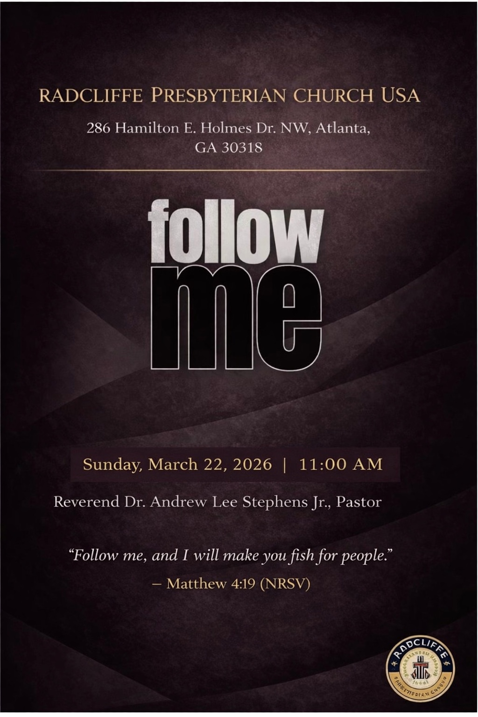
ORDER OF WORSHIP
────────────────────────────
Opening Prayer
Scripture Reading
Inspirational
Proclamation of the Word
Invitation
Confession
Apostles’ Creed
Congregational Song
Offering
Announcements
Charge
Blessing and Benediction
Postlude

LITANY OF CONFESSION
────────────────────────────
Leader: God of life and breath, You call what is dead to live again.
People: Yet we confess that we often live as though hope is gone.

Leader: You spoke life into a valley of dry bones.
People: But we confess that our faith sometimes feels dry and lifeless.

Leader: You invite us to cry out to You from the depths.
People: Yet we hide our sin and pretend we do not need Your mercy.

Leader: If You should mark our iniquities, O Lord, who could stand?
People: But with You there is forgiveness and redemption.
Leader: You have given us Your Spirit, the Spirit who brings life and peace.
People: Yet we confess that we often set our minds on the things of the flesh rather than the things of the Spirit.
Leader: In Jesus Christ You declared, “I am the resurrection and the life.”
People: Yet we confess that we sometimes live as though death and despair have the final word.
Leader: Lord, roll away the stones that seal our hearts.
People: Call us out of the tombs of fear, sin, and unbelief.
Leader: Breathe Your Spirit into us again.
People: Raise us to new life through Jesus Christ our Lord.
All: Amen.
CONGREGATIONAL SONG
────────────────────────────
Bless the Lord with me

Bless the Lord with me
Bless the Lord with me
Bless the Lord with me
Bless the Lord with me

Hallelujah
Hallelujah
Hallelujah
Hallelujah

Clap your hands with me
Clap your hands with me
Clap your hands with me
Clap your hands with me

Hallelujah
Hallelujah
Hallelujah
Hallelujah

Dance before the Lord
Dance before the Lord
Dance before the Lord
Dance before the Lord

Hallelujah
Hallelujah
Hallelujah
Hallelujah

SCRIPTURE READINGS
────────────────────────────
Fifth Sunday in Lent

First Reading — Ezekiel 37:1–14
Psalm — Psalm 130
Second Reading — Romans 8:6–11
Gospel — John 11:1–45

PARTICIPANTS
────────────────────────────
Worship Leader — Minister James Junior Koranteng
Scripture — Minister James Junior Koranteng
Music Ministry — Every Sunday Choir
Media Ministry — Director Reginald Simpson, Elder Charles Easley, Lamont Ryant, Elder Andrew Lee Stephens III
Proclamation of the Word — Rev. Dr. Andrew Lee Stephens Jr.
2TAKEWAYS PLUS
────────────────────────────

