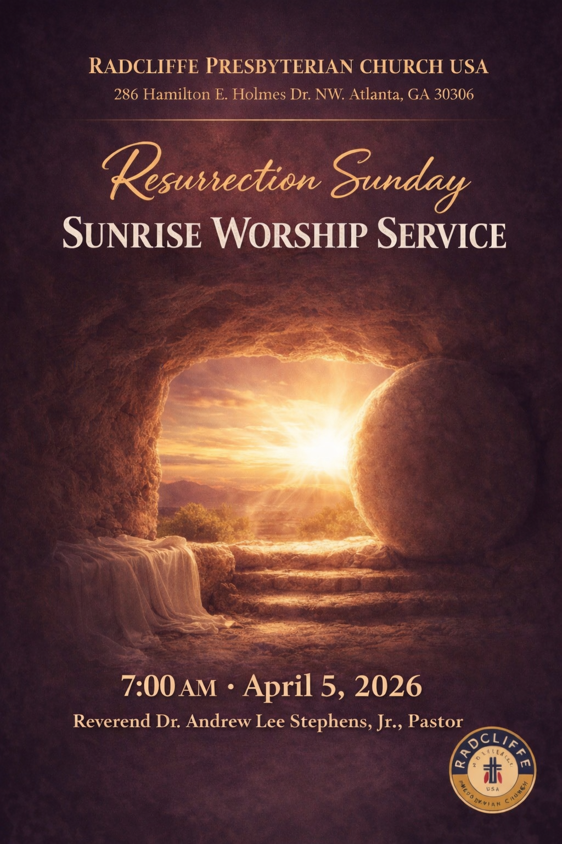
ORDER OF WORSHIP
────────────────────────────
Opening Prayer
Scripture Readings
Inspirational
Proclamation of the Word
Invitation
Confessional Song
Offering
Breakfast Prayer
Charge
Blessing and Benediction
Postlude

CONFESSIONAL SONG
────────────────────────────
I Surrender All
1 All to Jesus I surrender,
All to Him I freely give;
I will ever love and trust Him,
In His presence daily live.
Refrain:
I surrender all, I surrender all;
All to Thee, my blessed Savior,
I surrender all.
2 All to Jesus I surrender,
Make me, Savior, wholly Thine;
Let me feel Thy Holy Spirit,
Truly know that Thou art mine. [Refrain]
3 All to Jesus I surrender,
Lord, I give myself to Thee;
Fill me with Thy love and power,
Let Thy blessing fall on me. [Refrain]

SCRIPTURE READINGS
────────────────────────────
First Reading: Acts 10:34–43
Psalm: Psalm 118:1–2, 14–24
Second Reading: Colossians 3:1–4
Gospel: John 20:1–18

PARTICIPANTS
────────────────────────────
Worship Leader
Elder Cheryl Costen Hibbler

Scripture Reader
Elder Cheryl Costen Hibbler

Music Ministry
Every Sunday Choir

Media Ministry
Director Reginald Simpson
Elder Charles Easley Jr.
Trustee Lamont Ryant
Elder Andrew Lee Stephens III

Proclamation of the Word
Minister James Junior Koranteng
2TAKEWAYS PLUS
────────────────────────────

